|  |  |  |  |  |  |
| --- | --- | --- | --- | --- | --- |
| Date | 12-Dec-22 | | | Tester Name | Janette Paus |
| Environment | Penfax - Test 2 | | | Login used | <If different from the Tester> |
| Operating System | Windows | Version: 21H2 | Update Number: | | |
| Software Used | Select Software | Version: 107.0.1418.56 | Update Number: | | |
| Select Software | Version: | Update Number: | | |
| Application Release version | R22.4.1 | | | | |
| Test Case Title | E13.07 | | | | |
| Test Type | Regression | | | | |
| Test Scenario | Remove a Beneficiary | | | | |
| Expected Results | The new PEPP beneficiary is removed correctly. | | | | |
| Pass/Fail | Pass | | | JIRA# |  |

Search for any PEPP member that has a beneficiary listed.

Open that member profile, Under person profile🡪 Beneficiary🡪 Beneficiary Designations

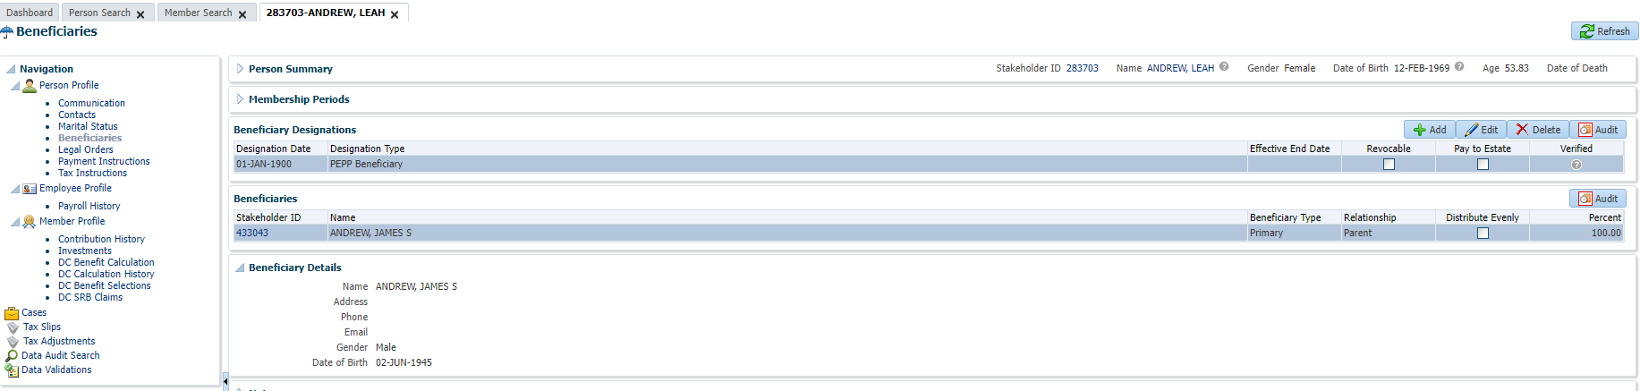

Delete beneficiary designation

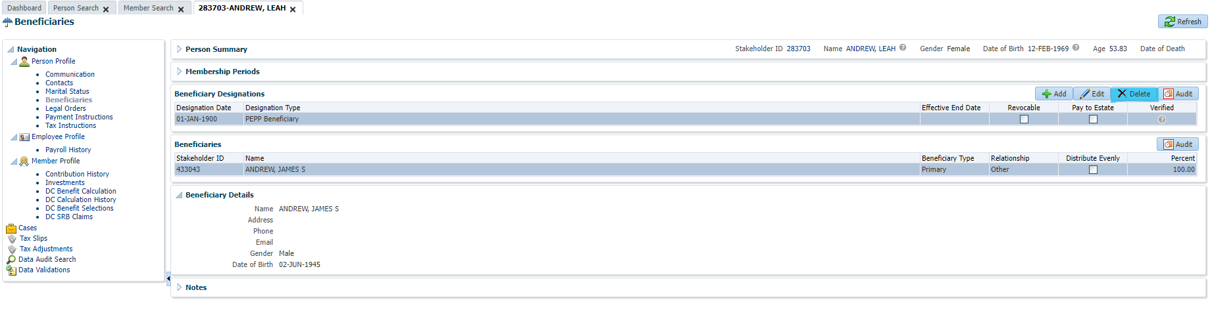

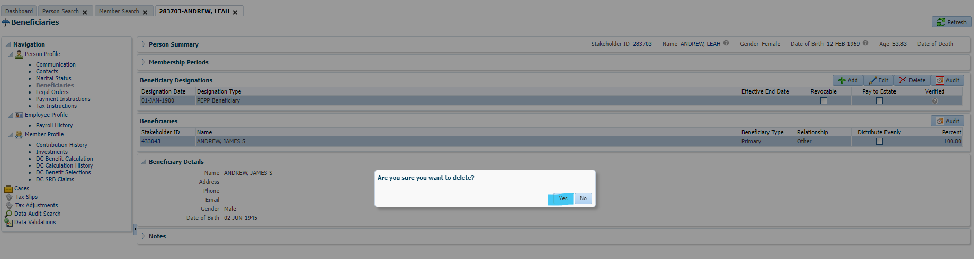

Confirm Beneficiary is deleted.

